**Unit 2 Exam: Tools of Geometry on the Coordinate Plane**

*You must show all your work to receive full credit.*

*40 points*

1. **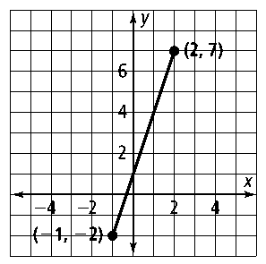***(4 points)* Use the diagram show on the right.   
   1. Find the length of the line segment to the right. Leave your answer in radical form.
   2. Find the midpoint of the line segment to the right.
2. *(2 points)* M is the midpoint of *AB* and is located at M(-1, 8). A is located at A(3,4). What is the coordinate of the other endpoint, B?
3. *(2 points)* In radical form, what is the distance between points *L*(8, 9) and *Z*(−10, 0)?
4. *(4 points)* Line segment XZ has endpoints X(-2, 1) and Z(4,10). Point Y divides the segment in the ratio 2 to 1. What are the coordinates of point Y? [*The use of the set of axes is optional]*

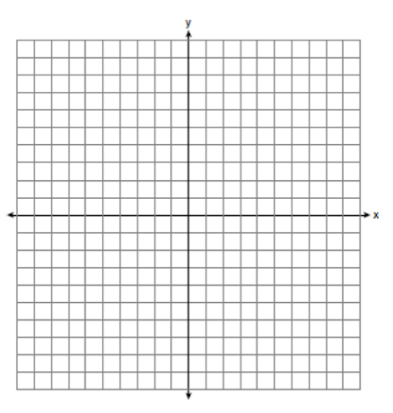

*(12 points)* For questions 5 - 10 use the diagram on the right where *a//b & c//d.*

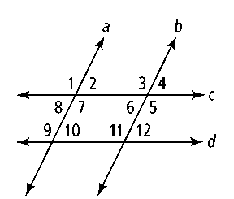

1. ∠2 and ∠10 are what kind of angles?
2. ∠3 and what angle are alternate interior angles?

7. *m*∠2 = 25˚ and *m*∠3 = _________ ? 8. *m*∠4 = 10˚ and *m*∠11 = _________ ?

9. *m*∠1 = 100˚ and *m*∠9 = _________ ? 10. *m*∠5 = 110 ˚ and *m*∠8 = __________ ?

1. *(4 points)* Find the equation of the line that passes through points (2, 1) and (–3, 5). *You may use point-slope or slope-intercept form.*
2. *(6 points)* Four points are located on a coordinate plane at

*L*(10, 7), *M*(4, –2), *Q*(2, 6), and *R*(–8, –1).

a) Find the slopes of  and *.*

b) Determine whether  and  are *parallel, perpendicular,* or *neither.*

c) Explain why in a complete sentence.

15. *(2 points)* What is the equation of the line parallel to *y* = −6*x* + 2 that contains the point (1, 2)?

16. *(4 points)* contains points (2, 1) and (−1, −8). What is the equation of the line perpendicular to ** that contains point (0, 2)?